Mini Project (Final Task)
Problem Statement:
Build a complete pipeline that reads a CSV file from Blob Storage and processes it using Azure Data Factory.
Step 1: Source Setup:
I used the same source container (source-container-week4) which already had the CSV file (Sample - Superstore.csv) uploaded in the blob storage. This served as the input for the pipeline.
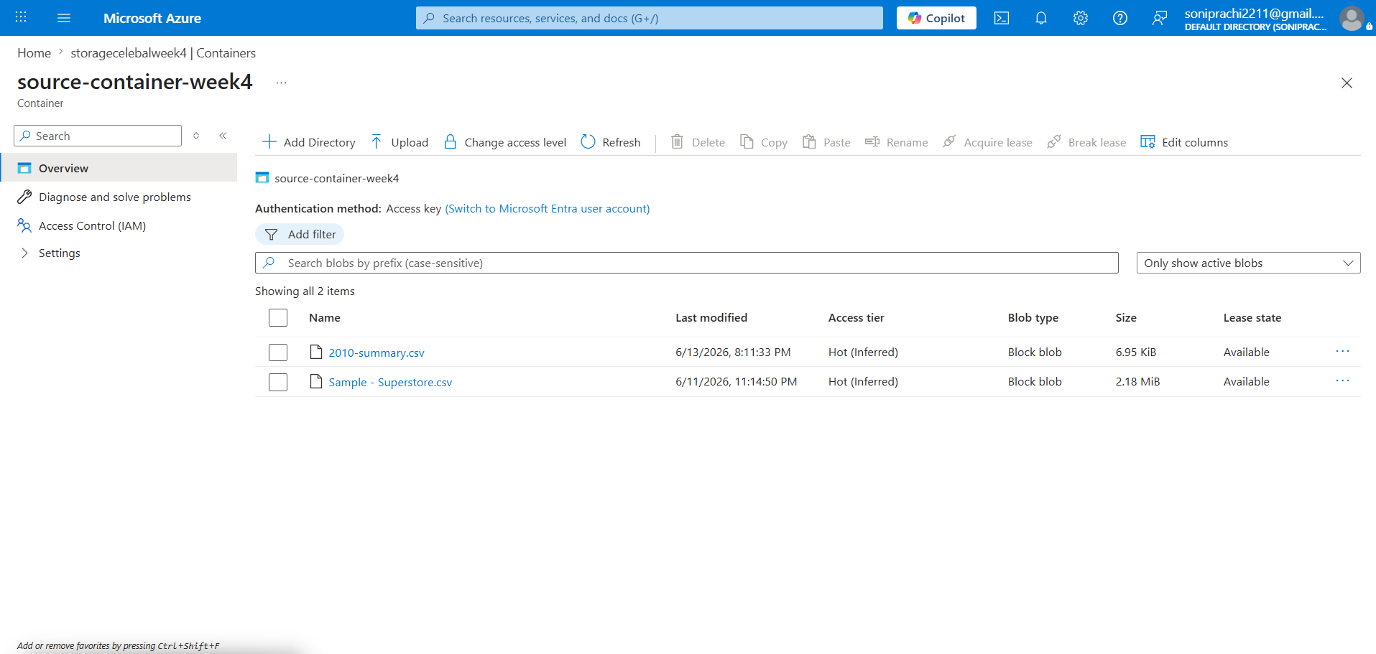

Step 2. Linked Service and Dataset:
I used the existing BlobStorage_Week4 Linked Service to connect Azure Data Factory to the storage account. The DS_source dataset was used to read the source file, and the DelimitedText1 dataset was used to save the copied file in the destination container.
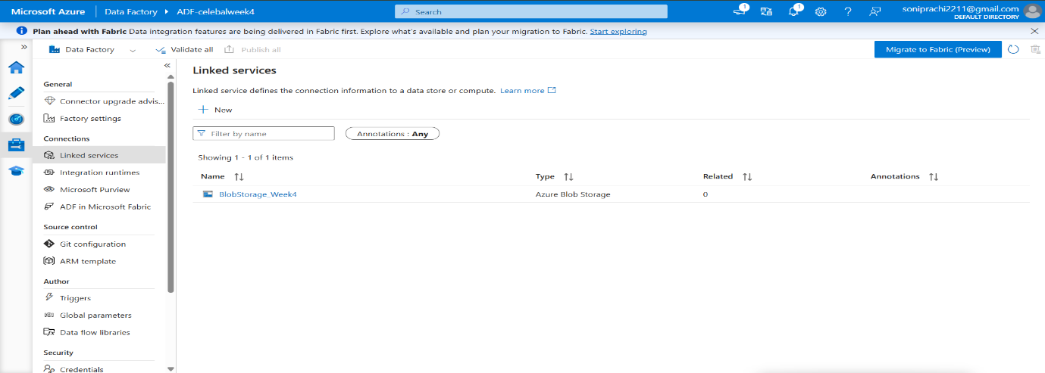
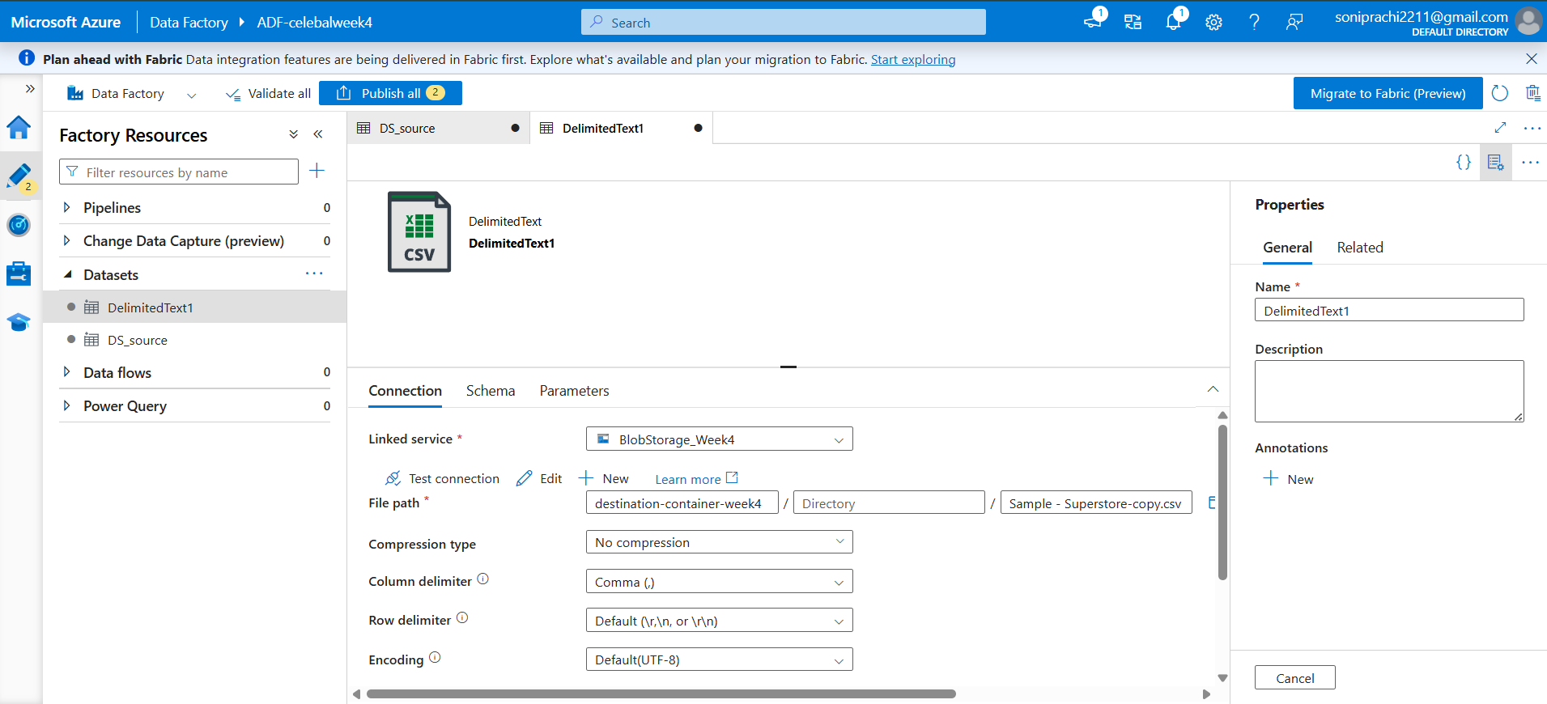

Step 3. Copy Data + Metadata check:
I created a pipeline named pipeline-week4. First, I used the Get Metadata activity to verify that the source file was available and to check its details. After that, I used the Copy Data activity to copy the file from the source container to the destination container.

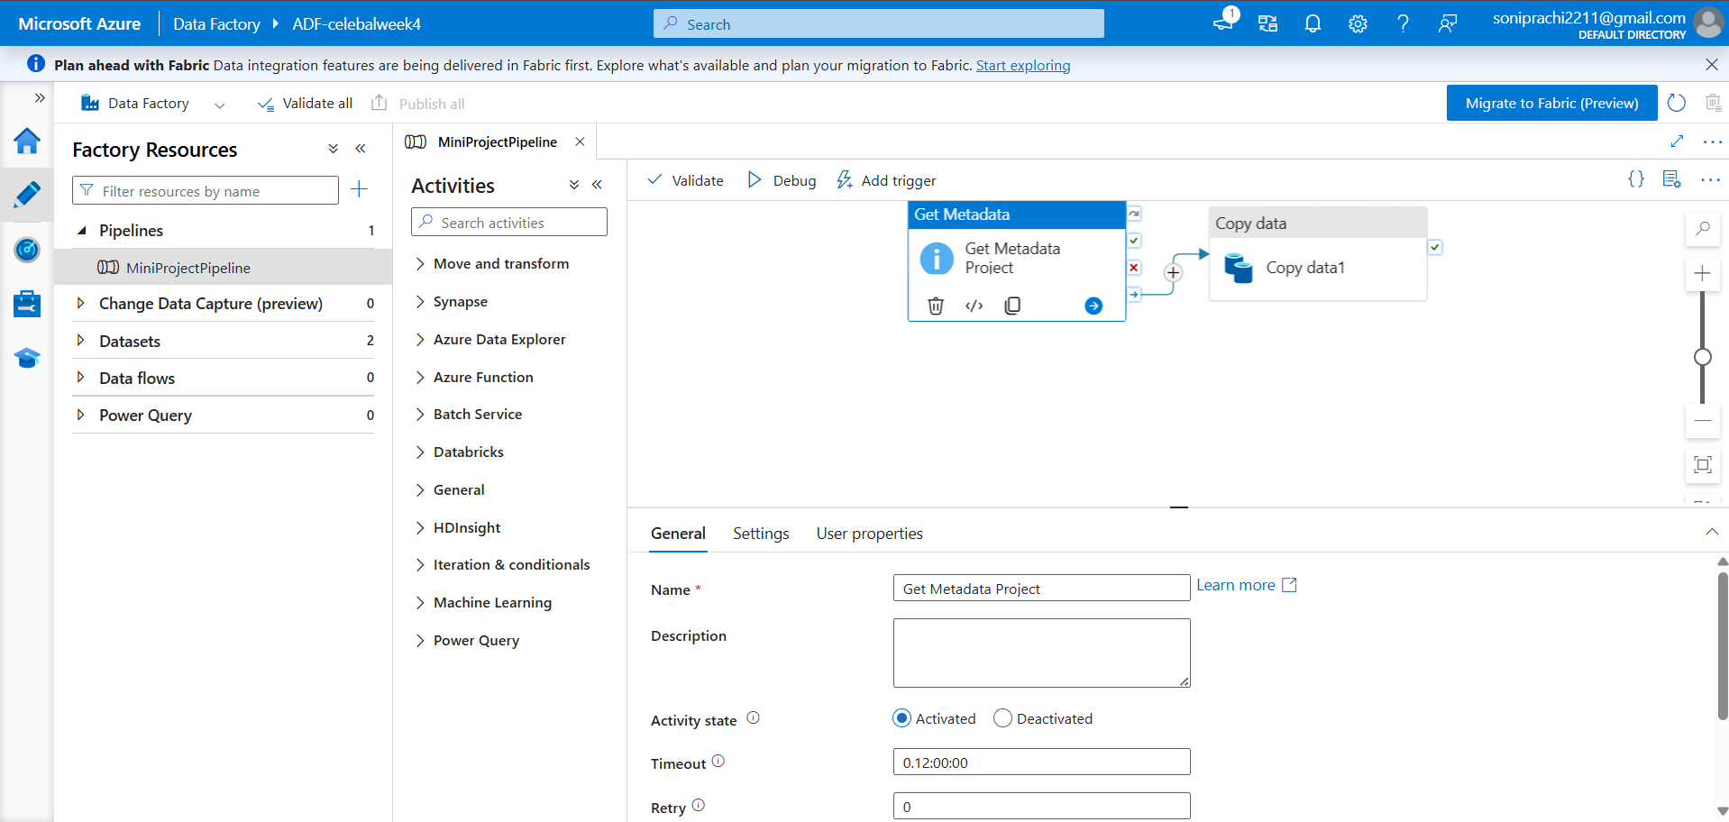

Step 4: Pipeline Execution:
I executed the pipeline-week4 in Debug mode. The Get Metadata activity ran successfully and verified the source file details, and the Copy Data activity successfully copied the file to the destination container. Both activities completed without any errors.
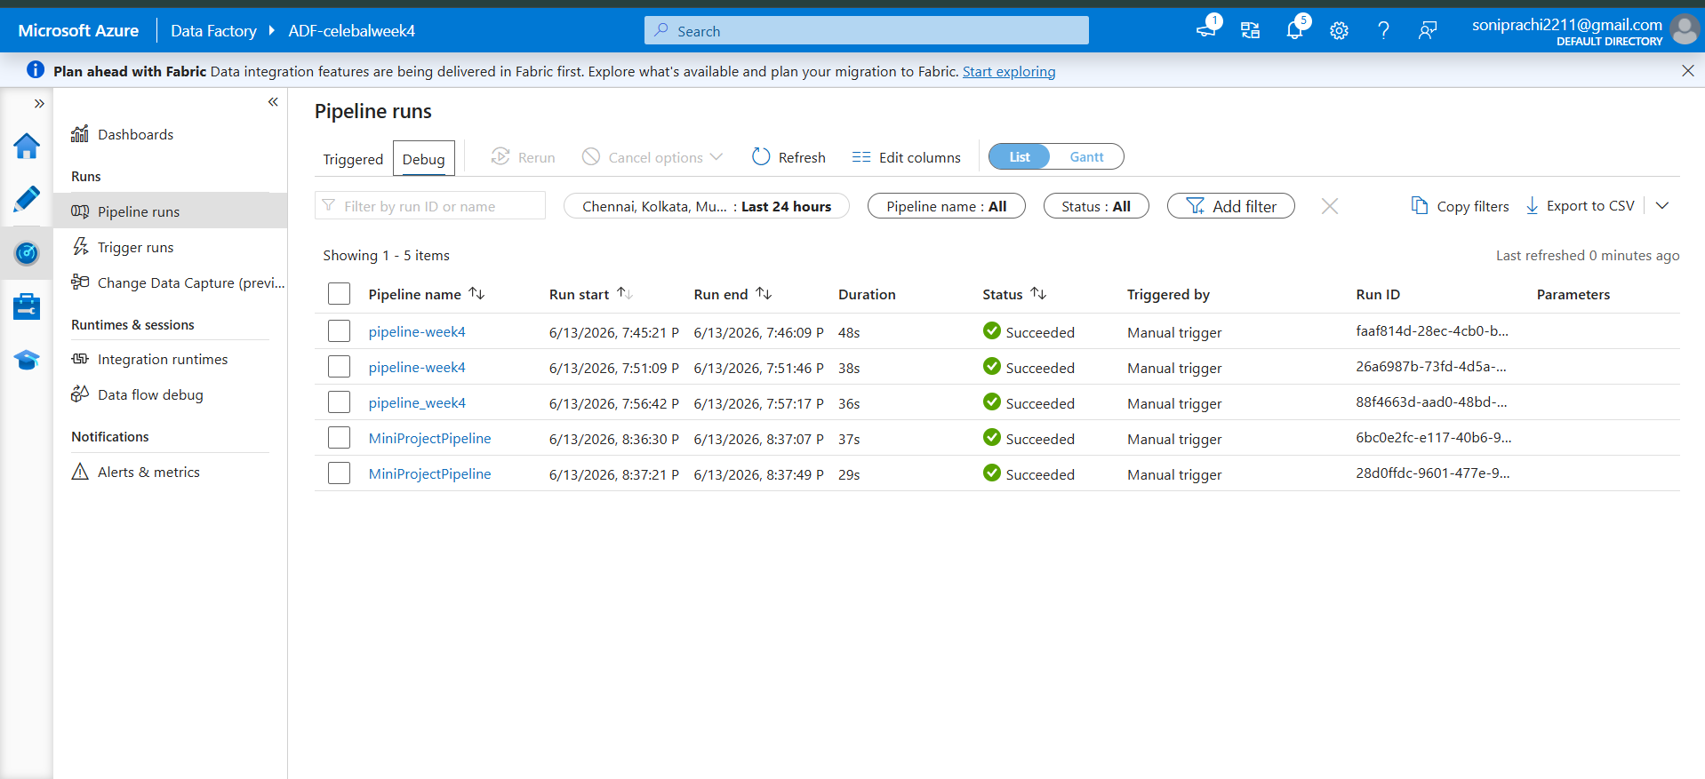
Step 5: Output Validation:
I verified the destination container and confirmed that the CopyEmployeeData file was copied successfully. This confirmed that the complete data transfer process worked correctly from source to destination.
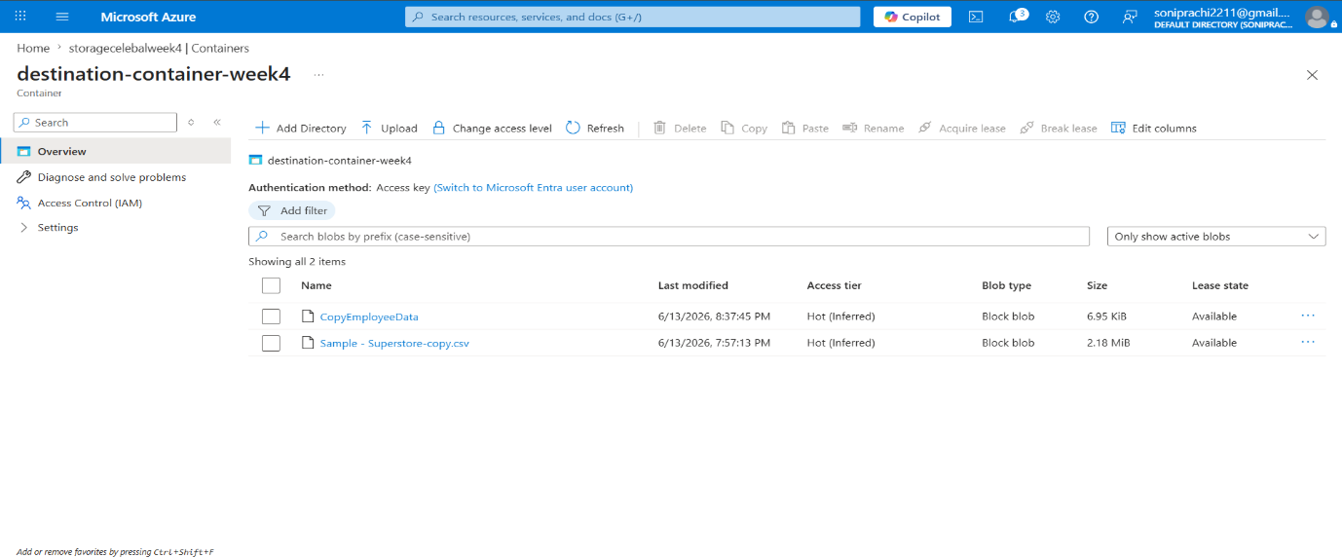
Summary:
In this mini project, I created an Azure Data Factory pipeline to read a CSV file from Azure Blob Storage and process it. First, I used the Get Metadata activity to verify the source file and check its details. Then, I used the Copy Data activity to copy the file to the destination container. The pipeline executed successfully in Debug mode, and I verified that the file was copied correctly by checking the destination location.

